**Money and Measures of the Money Supply**

no activity for this module (MC questions only)

**The Demand for Money**

Activity 1

Suppose the real interest rate was relatively high such as line A in the diagram below.

Place a dot somewhere along line A to represent where the demand for money might be and label the dot C.

Suppose the real interest rate was relatively low such as line B in the diagram below.

Place a dot somewhere along line B to represent where the demand for money might be and label the dot D.

Finally, connect the two points labeled C and the two points labeled D.

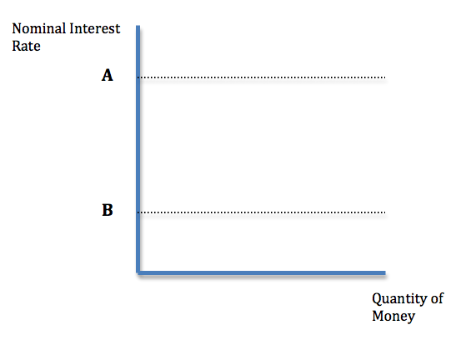

**SHOW ANSWER**

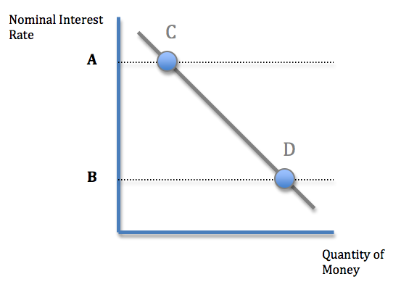Activity 2

**Show Animation**

(animate the point traveling upward and to the left from these two points along the line)

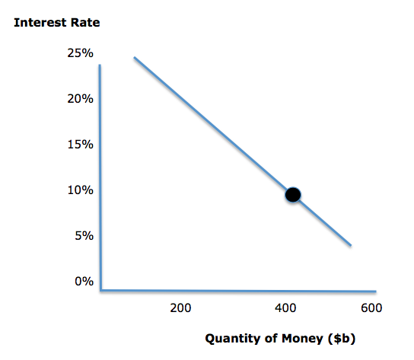

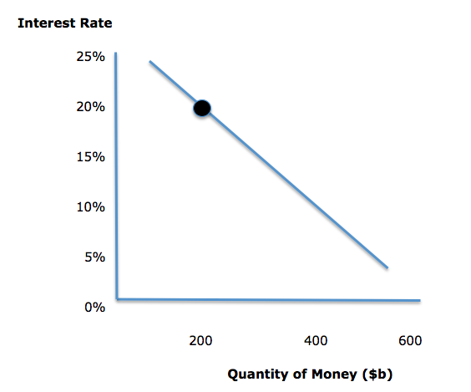

**Based on the animation presented, which of the following statements best describes this event?**

The demand curve for money has shifted to the left.

The quantity of money demanded has increased from $200 billion to $400 billion.

**The quantity of money demanded has decreased from $400 billion to $200 billion.**

The interest rate has decreased from 20% to 10%.

The demand curve for money has shifted to the right.

Activity 3

**Changes in Money Demand**

click on the arrows below to explore how economists illustrate changes in the demand for money.

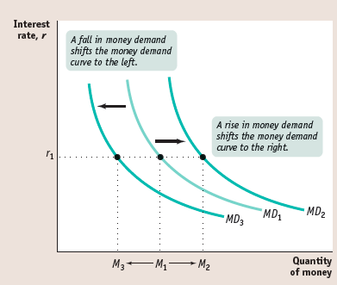

**Notes to programmer:**

**Animate the concept illustrated in the photo, using three slides:**

**Slide one** shows only the MD1 curve.

**Slide two** shows the MD1 curve but also the MD2 curve, with the label “when money demand rises, the money demand curve shifts to the right.”

**Slide three** shows the MD1 curve but also the MD3 curve, with the label “when money demand falls, the money demand curve shifts to the left.”

**Change** the labels (names) of the curves, as follows:

change Md1 to D1, change Md2 to D2, and change Md3 to D3

**Change** the slope of all three curves to make them downward sloping lines, the same as the previous money demand curves.

**The Inverse Relationship between Bond Prices and Interest Rates**

Activity 1

Describe the relationship between the following economic variables by properly placing the arrows to indicate an increase or decrease:

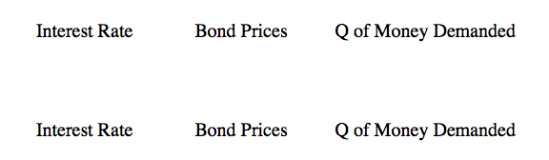

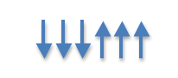

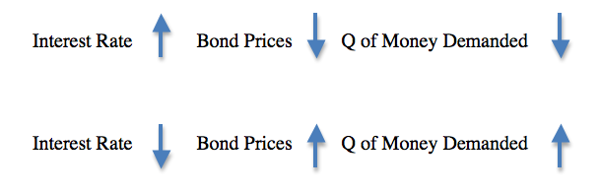**Check Answer (automatically graded)**

**Answer (for grading purposes)**Activity 2

Copy the interactive activity from “Loanable Funds” LC2. It looks like this:

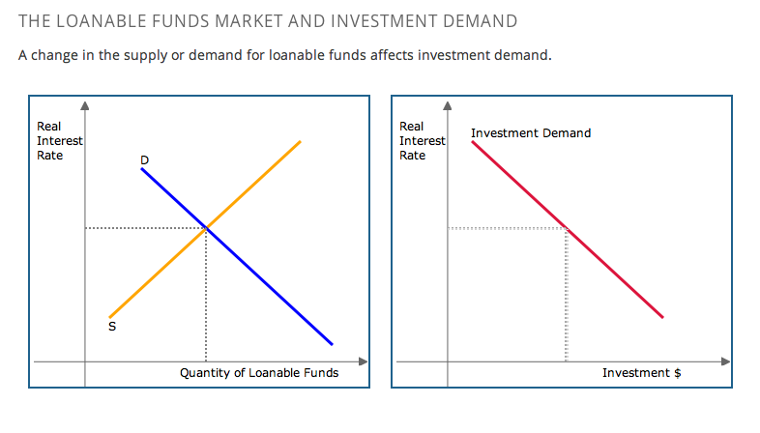

Change the labels on the LEFT graph, as follows:

change “Quantity of Loanable Funds” to “Quantity of Money”

Make the “S” line totally vertical instead of downward sloping.

Change the labels on the RIGHT graph, as follows:

change “Real Interest Rate” to “Price of Bonds”

change “Investment $” to “Quantity of Bonds per period”

Call the line on the RIGHT graph “D” (for demand)

Add another line (upwards sloping) on the RIGHT graph and label it “S”

**most important part:** reverse the connection between the two graphs. When the user shifts the “D” line LEFTWARD on the LEFT graph, the “D” line on the RIGHT graph should shift RIGHTWARD. This signifies that money demand is opposite of bond demand.

The graphs on the initial default screen should look like this: 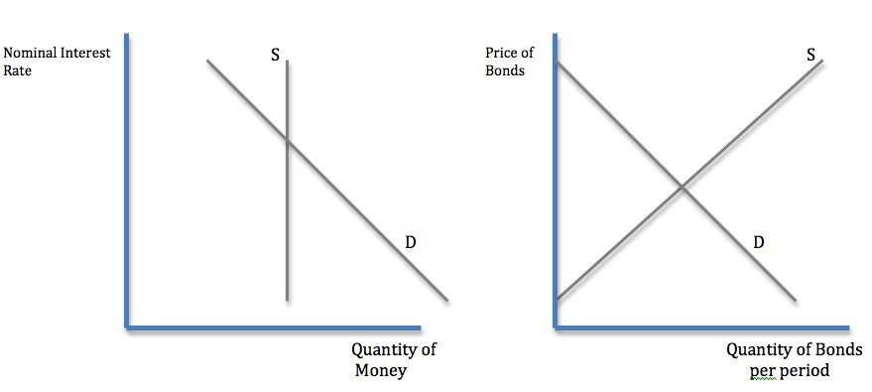

and when the user moves the D line on the LEFT graph LEFTWARD, the D line on the RIGHT graph should shift RIGHTWARD, like this:

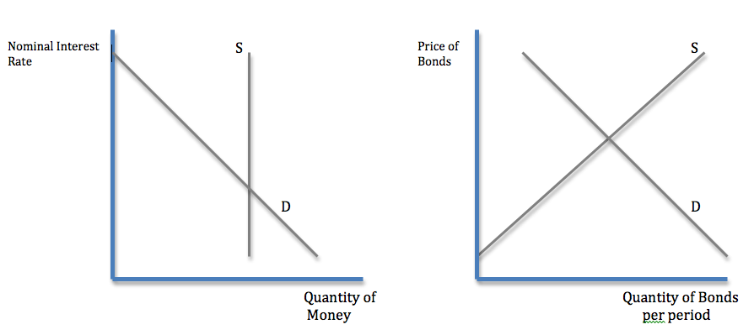

Please note that the D line on the RIGHT graph does not move as much as the D line on the LEFT graph does. It is not a 1 to 1 relationship. When Money demand decreases, the price of bonds does not go up as much as demand decreased.

**Equilibrium in the Money Market**

Activity 1

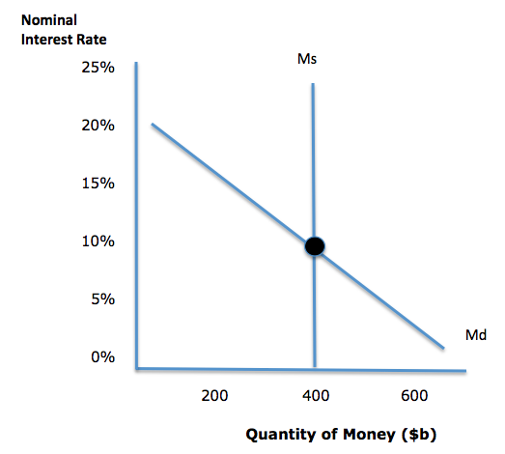

The money market is in equilibrium at an interest rate of 10%.

Illustrate a decrease in money demand by moving the appropriate curve in the graph above.

Then answer the following question:

The quantity of money demanded will be ____ and the interest rate will be ____

less than $400 billion…less than 10%

exactly $400 billion…exactly 10%

more than $400 billion…less than 10%

less than $400 billion…more than 10%

more than $400 billion…more than 10%

**Check Answers**

**Note to Programmer:**

This graph is interactive, allowing the user to shift either curve to the right or left.

The answer to this question would be the money demand curve (line Md) shifting to the left. Once they make a choice, the user can click on **Check Answers** to grade.

Activity 2

Watch the animation below and answer the questions that follow.

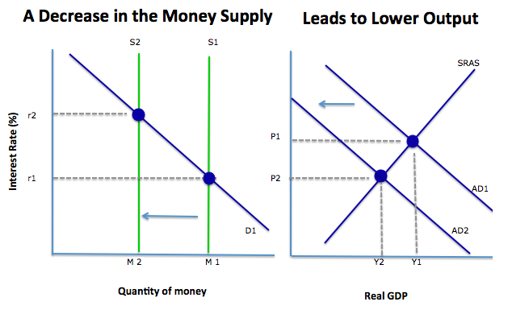

**This animation illustrates which of the following events?**

A decrease in the quantity of money demanded and a rise in the interest rate

A decrease in the quantity of money demanded and a fall in the interest rate

An increase in the quantity of money demanded and a rise in the interest rate

An increase in the quantity of money demanded and a fall in the interest rate

**Economists illustrate a decrease in the money supply as:**

a leftward shift of the vertical money supply curve

a rightward shift of the vertical money supply curve

a leftward shift of the upward sloping money supply curve

a rightward shift of the upward sloping money supply curve

a leftward shift of the production possibilities curve

**Check Answers**

**Note to programmer**: begin by illustrating the line S1 only (no S2) along with the line D1, the label “M1” and also the corresponding point of intersection at S1 & D1 plus the adjacent dashed line with r1 displayed. Hold for a few seconds, then animate line S1 shifting leftward, but the labels “S1” and “M1” disappear. The dashed line also disappears and the “r1” label disappears. Once the leftward shift of the vertical supply curve reaches its destination, show the “r2” label and the dashed line next to it, along with the “S2” and “M2” at the bottom.

Activity 3

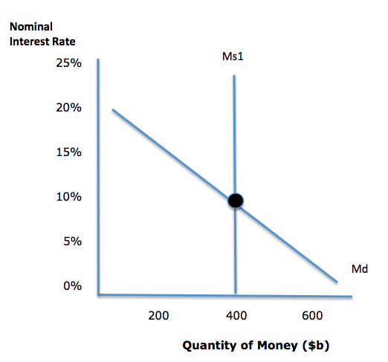

The United States economy is currently in a natural rate of growth. The money market is currently in equilibrium with an interest rate of 20%. At this interest rate, a quantity of $200 billion is demanded. Suppose people start losing faith in the banking system. What effect will this have on the nominal interest rate in America?

**Show Answer**

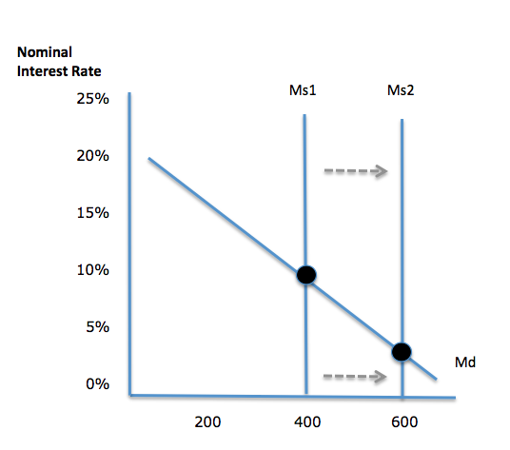

The quantity of money demanded will increase, while the interest rate will fall.